Basics of Bridge

1. Bridge = Repeater + functionality of reading MAC address
2. Layer 2 device
3. It is also used for interconnecting two LANs on the same protocol
4. Two port device
5. Types:
   1. Transparent bridges
      1. These are the bridges in which the stations are completely unaware of the bridge’s existence
      2. Reconfiguration of the stations is unnecessary even if bridge is added or removed from network
   2. Source routing bridges
      1. In these bridges, routing operation is performed by the source station and the frame specifies which route to follow.

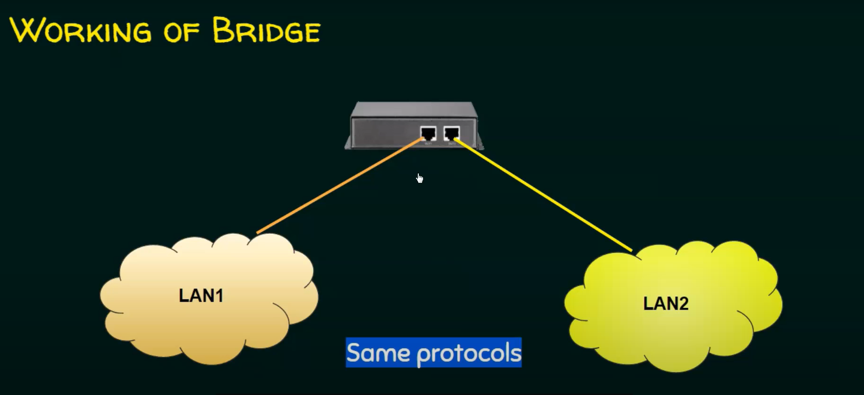

Difference between router and bridge

Bridge is a layer 2 device dealing with MAC addresses and connects the two LANs that have the same protocol.

Router: Different protocols, and layer 3 device, deals with IP addresses.